*Lesson 16*

63.

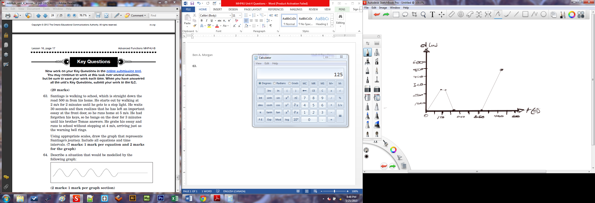

From his home to the stooping light:

From waiting at the stop light:

From running home because he left his essay:

From waiting for Thomas to answer the door:

From running to school after getting the essay:

As a piecewise function:

64. A situation that would be modelled by the graph would be a time vs. height graph of some seaweed in a lake getting stuck to the edge of a dock. Initially the seaweed ascends and descends due to the waves. As it rises, it sticks to the edge of the dock and then stays there.

65. a)

|  |  |
| --- | --- |
| X (in seconds) | Y (in metres) |
| 0 | 50 |
| 1 | 55 |
| 2 | 50 |
| 3 | 35 |
| 4 | 10 |
| 5 | -25 |

b) A negative value represents that she is no-longer I the air and has already hit the water. It does not represent the depth to which she may have dived.

c)

|  |  |
| --- | --- |
| X | Y (in metres per second) |
| 0 to 1 | 5 |
| 1 to 2 | -5 |
| 2 to 3 | -15 |
| 3 to 4 | -25 |
| 4 to 5 | -35 |

d) Her speed changes from positive to negative after one second.

e) This change represents that she is no longer ascending, but is now descending to the water.

f) She hits the water between 4 to 5 seconds.

g) Her average speed in the half-second before she hit the ground was -35 metres per second.

h) Her average speed from t=0 to t=2 is 0 because that was the length of time in which she had ascended and then descended back to her initial height.

i) By removing the direction so that the vector is a scalar and then averaging the speed instead of her velocity; by disregarding her up-down motion.

*Lesson 17*

66. a) For the 1st second:

For the 2nd second:

For the 3rd second:

For the 4th second:

For the 5th second:

For the 6th second:

b) The speed changes from positive to negative because the flare is accelerating downwards. The speed switches to negative because it is now moving down now instead of up.

c) The flare reaches its maximum height when the rate of change is equal to zero.

d)

e) The significance in answer (d) states that the rate of change at is zero which would indicate that the maximum for is .

67. a)

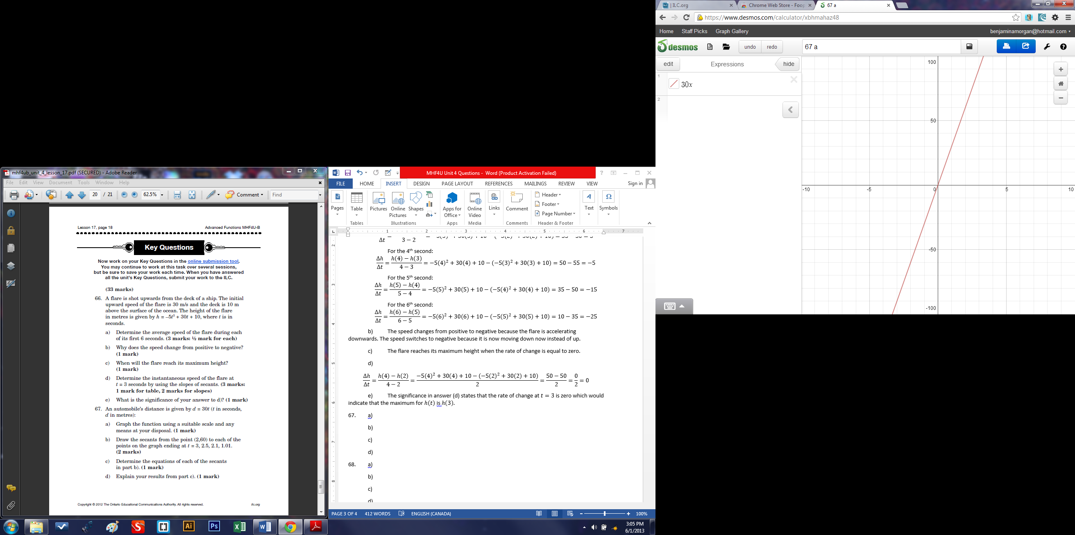

b)

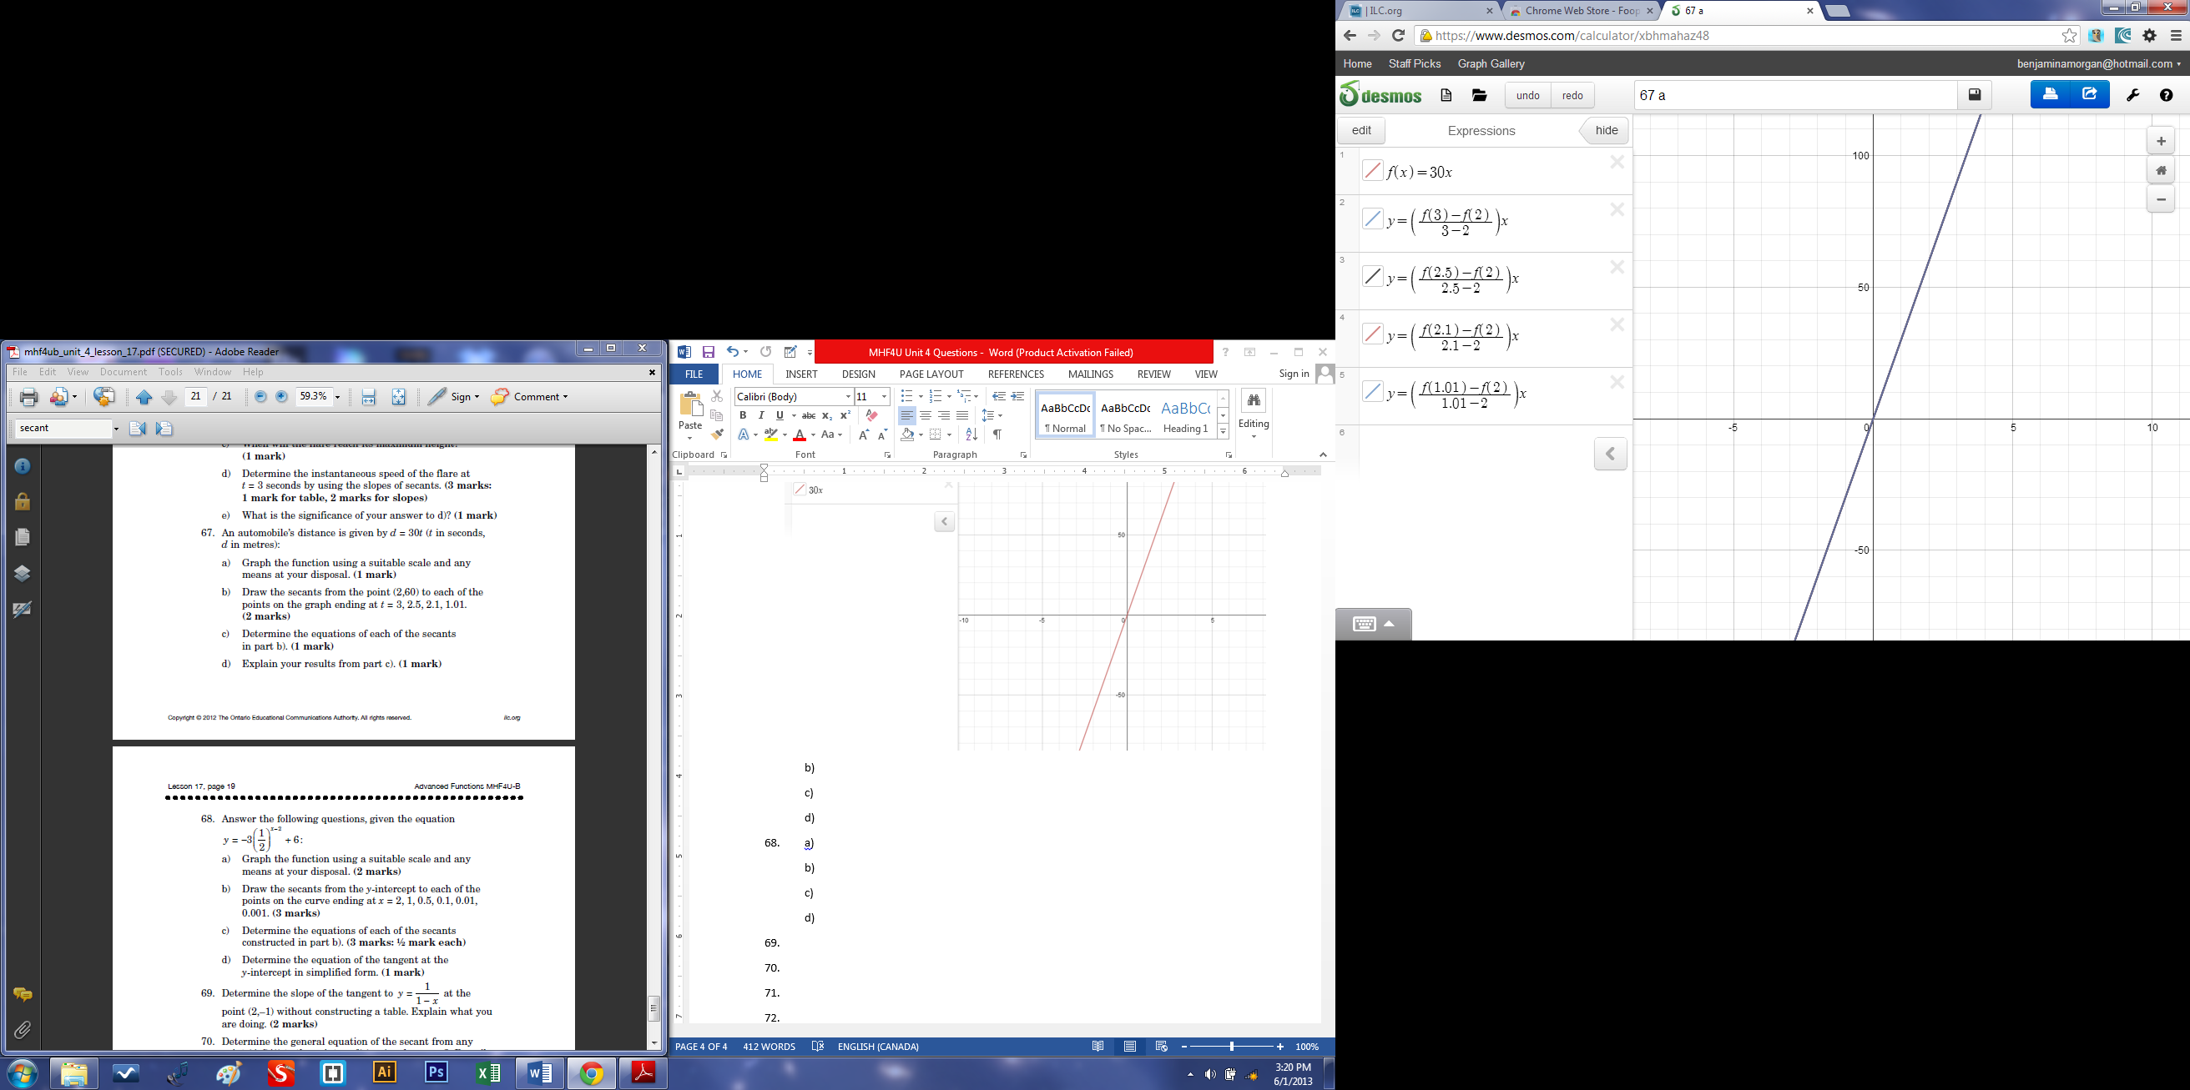

c)

For :

For :

For :

For :

d)

The results from part c) indicate that the equations of each of the secants were all equal to the equation for calculating the automobile’s distance.

68. a)

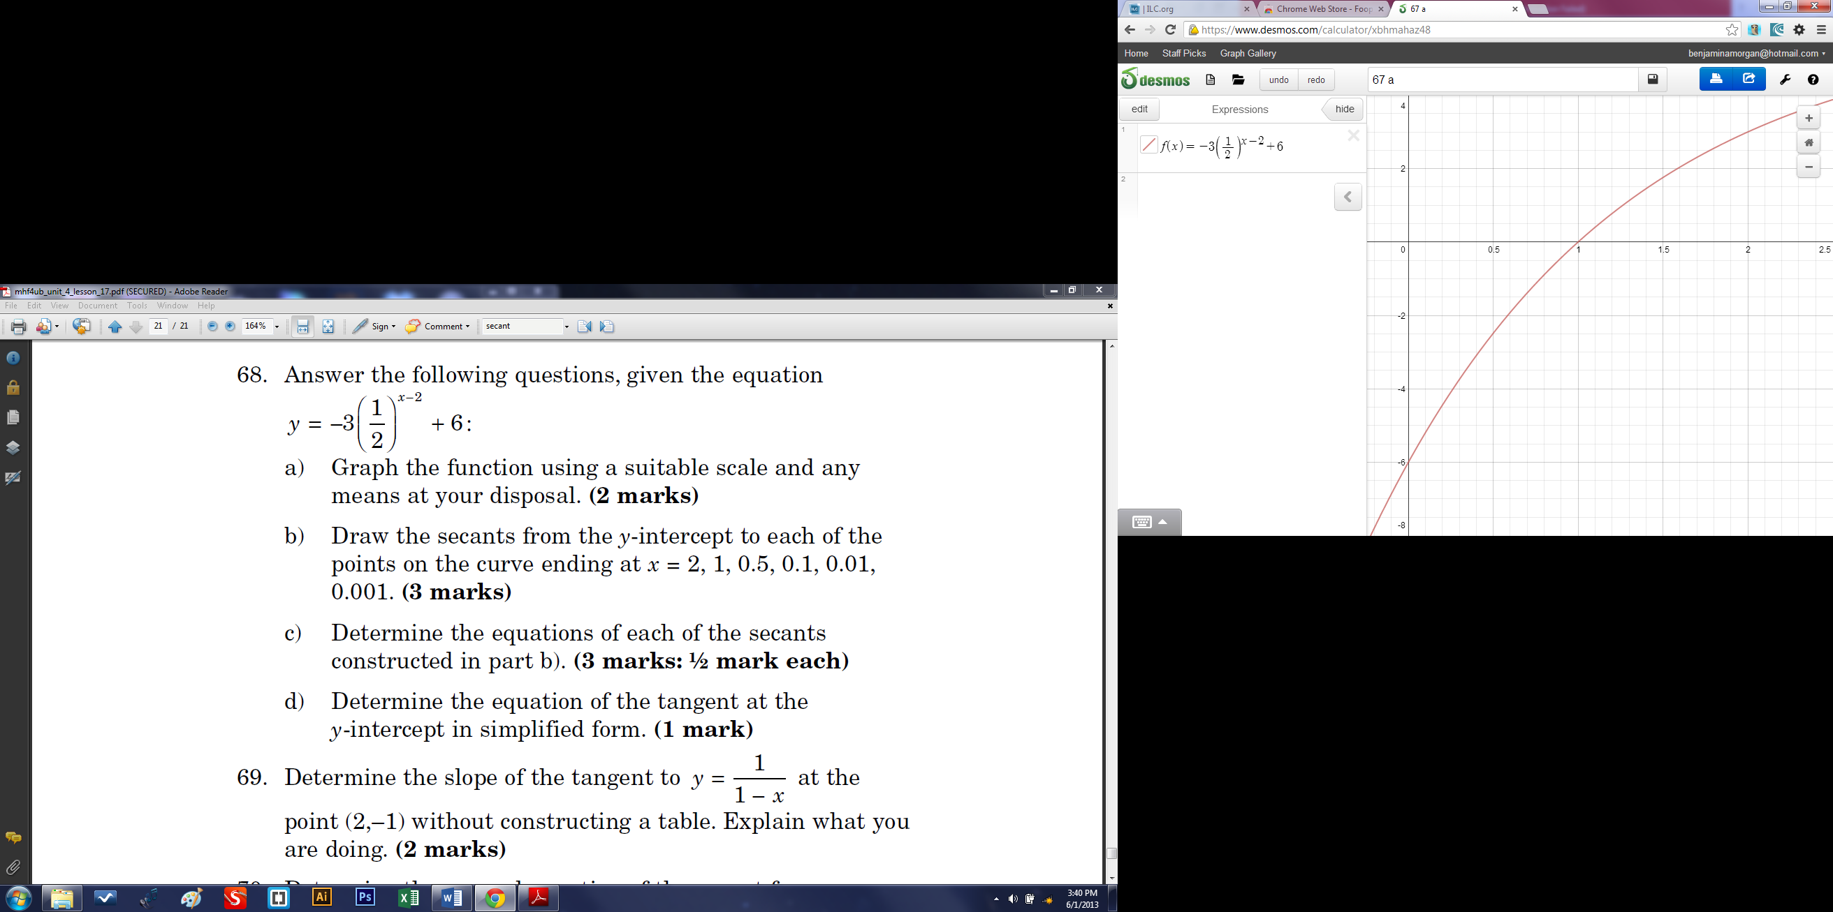

b)

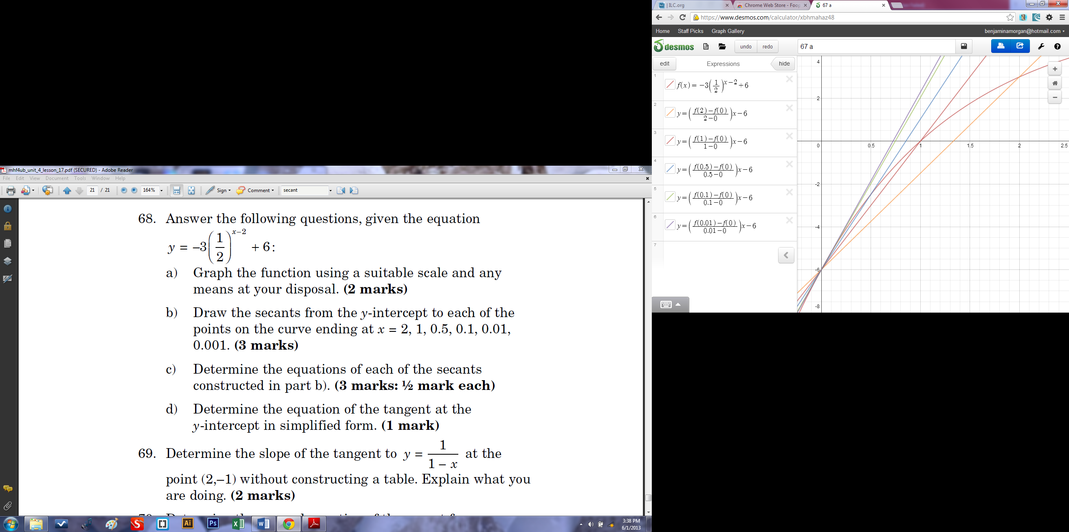

c)

For :

For :

For :

For :

For :

d) The equation of the tangent at the y-intercept is:

69.

And let and,

Instead of using a graph, I created an algebraic model of and then let the displacement or change, , equal zero which gave me an equation, , to identify the slope. I then substituted for and let the output equal the slope; .

70.

For , let and,

71.

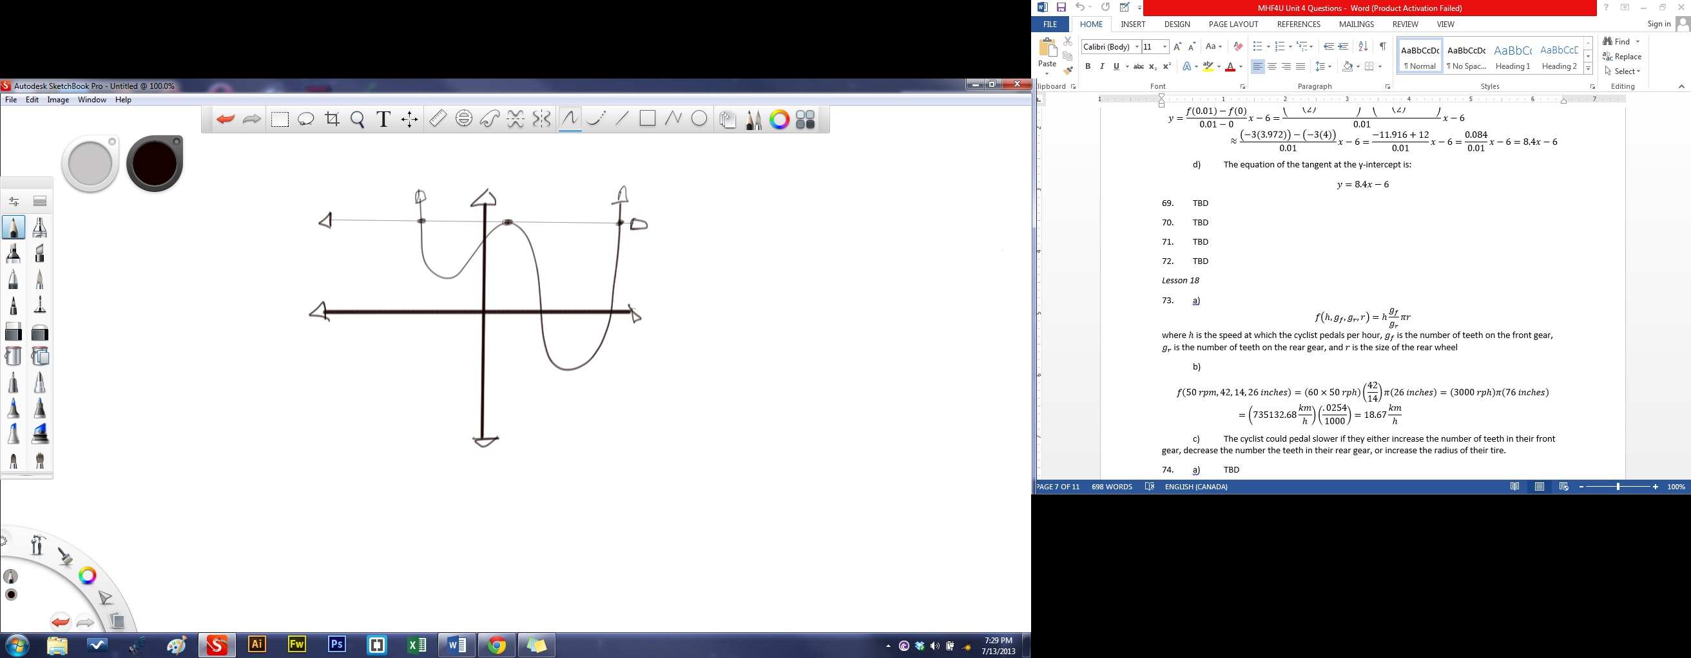

72.

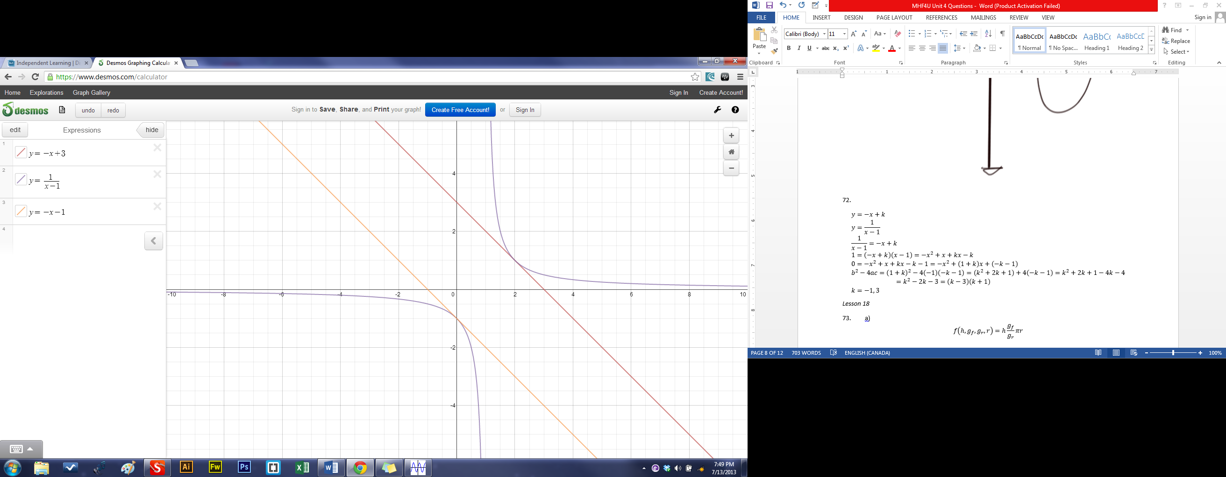

*Lesson 18*

73. a)  
where is the speed at which the cyclist pedals per hour, is the number of teeth on the front gear, is the number of teeth on the rear gear, and is the size of the rear wheel

b)

c) The cyclist could pedal slower if they either increase the number of teeth in their front gear, decrease the number the teeth in their rear gear, or increase the radius of their tire.

74. a) Letting the positive direction point upward and the origin being the ceiling,

b)  
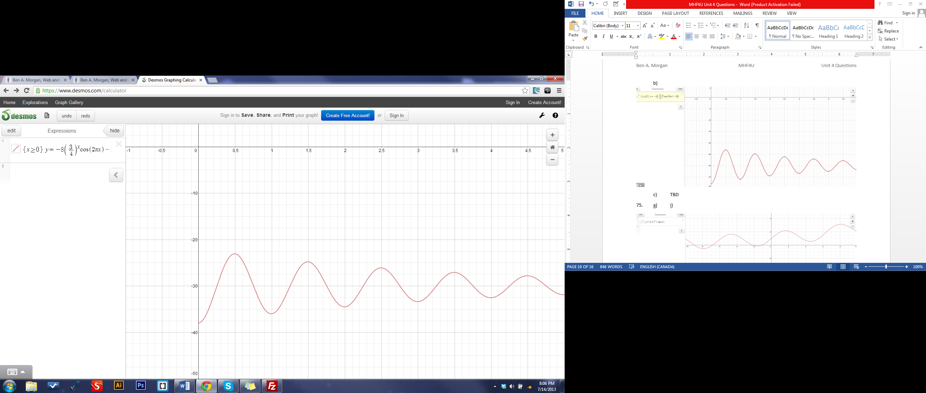

c) After sixty seconds, the distance of the spring will have approached 30 centimetres from the ceiling.

75. a) i)

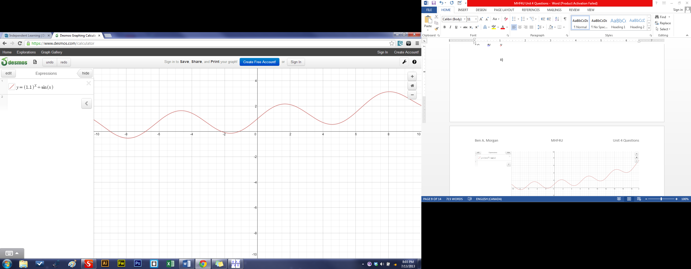

ii)

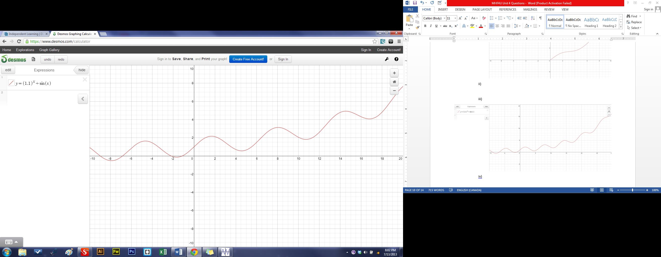

iii)

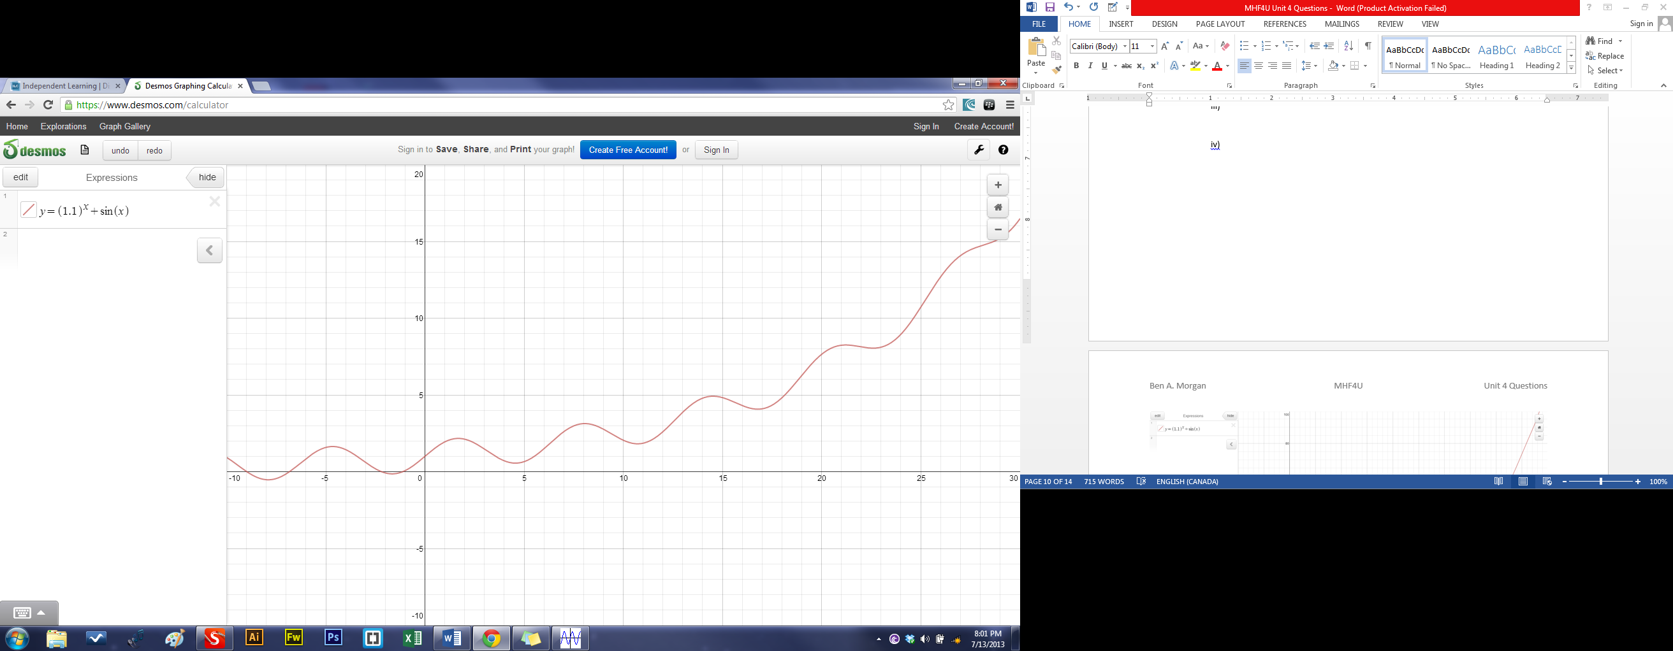

iv)

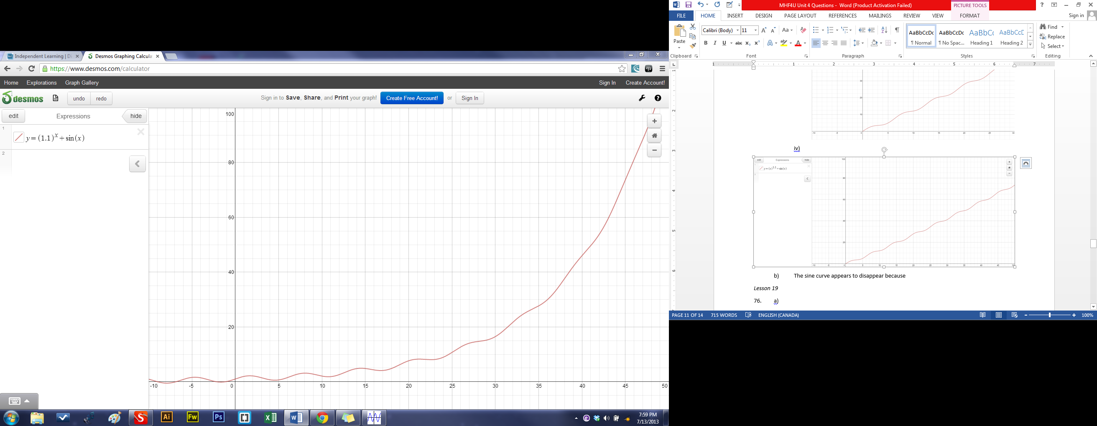

b) The sine curve appears to disappear because the exponential function, , begins to take have a larger effect on the output as increases versus the sine function, .

*Lesson 19*

76. a)

b)

c)

d)

e)

f)

g)

77. a) i)

ii)

iii)

b)

78. a)

b)

79. a)

b)

c)

80. a)

b) The first function, , applies a trigonometric output to ; the sine function. inverses the sine function and then makes the negative outputs from positive.

c)

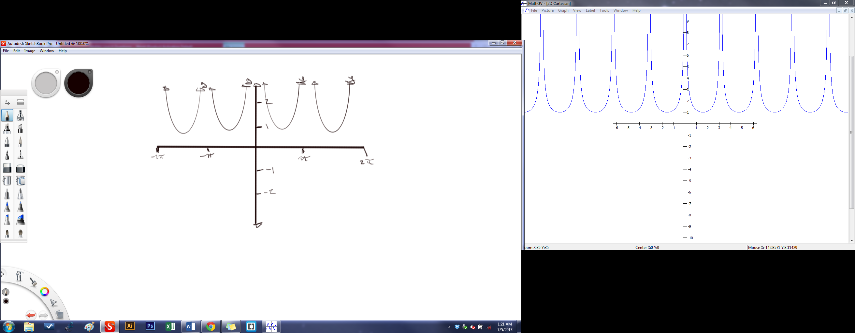

81. a)

b)

c)

d)

*Lesson 20*

82. a) i) Using Excel 2013,

ii) Using Excel 2013,

iii) Using Excel 2013,

iv)

b) i)

ii)

iii)

c) Since a negative answer would indicate that the value of the van would cost them if they sold it. Therefore the linear expression is not valid. Since the van can only decrease in value and not increase, then therefore the quadratic expression is not valid. The answer that is most reasonable is the exponential function which does not create a negative value and does not have an interval of increase.

d) The function that provides the best model is the exponential function.

83.

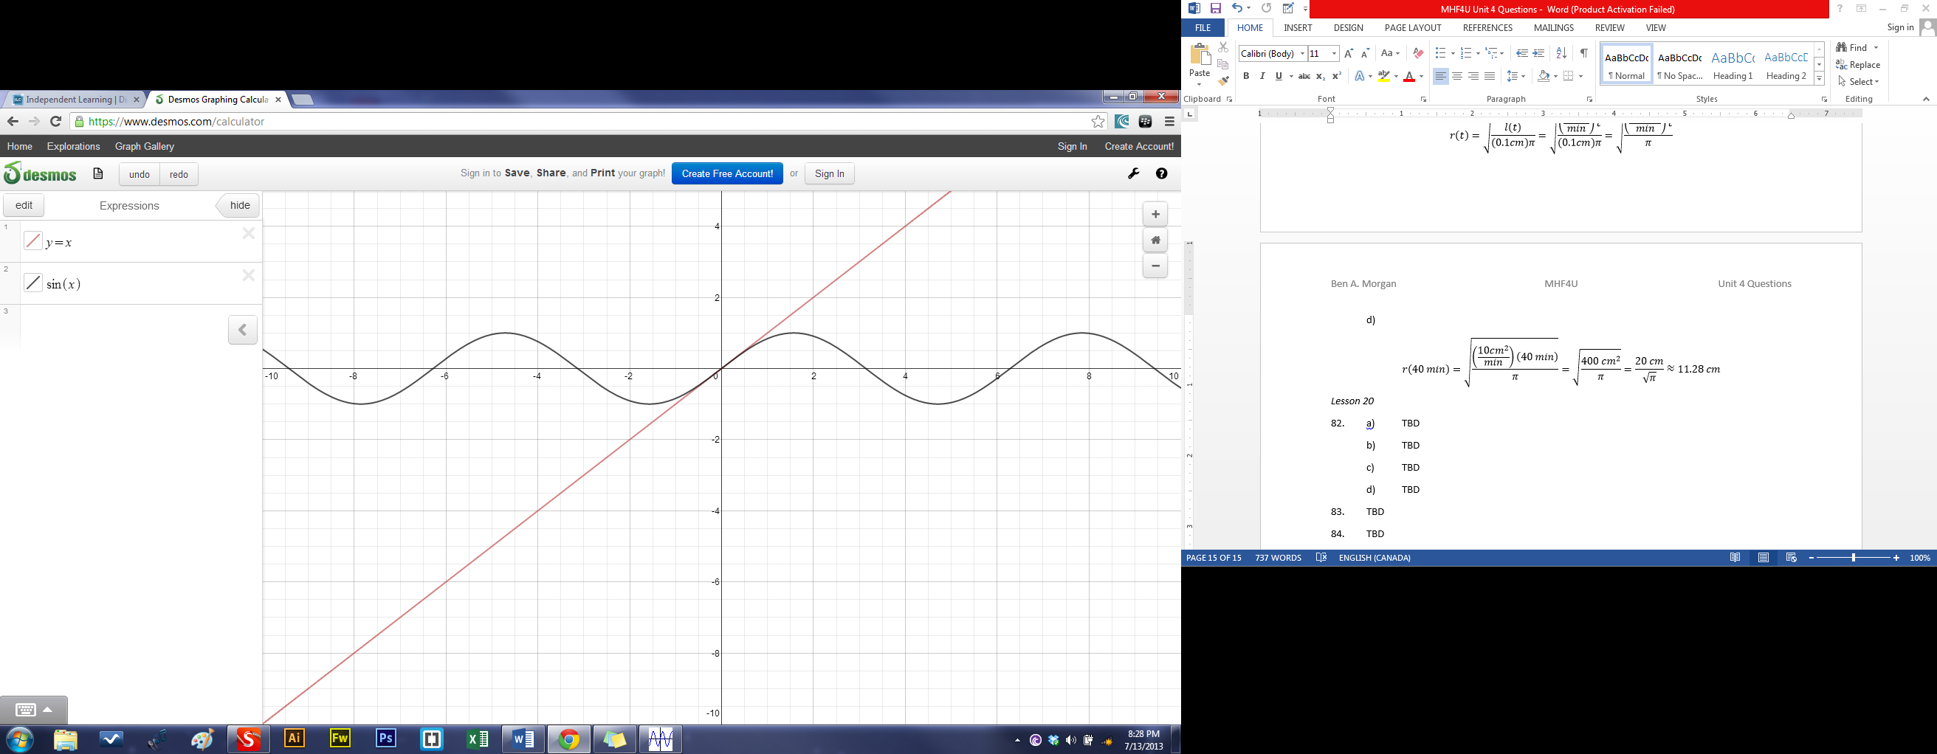

The regions where is .

84.

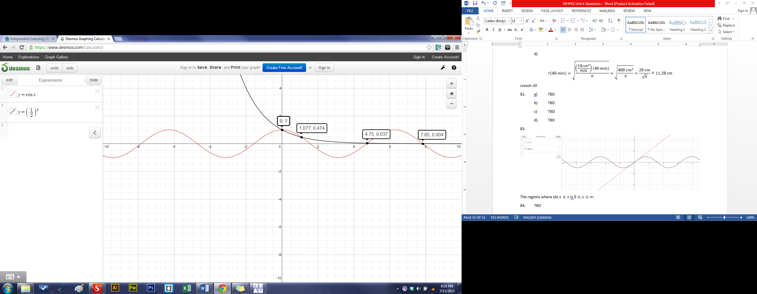

There are an infinite number of points that intersect and because ’s end behavior is the same for ’s in the positive direction.